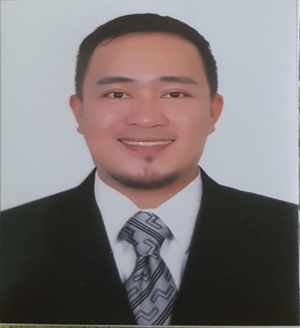
NAPOLEON GIMENO BERNADAS, JR.
56 Edgedale Plains #16-12 Singapore 828822
Mobile No.: 94267463
E-mail Address: nbernadas@yahoo.com

OBJECTIVES:
To utilize my skills and potentials as an experienced medical practitioner and trained reimbursement and direct billing claims executive in medical insurance field.

PROFILE:
Dedicated insurance professional with 10 years of experience processing and evaluating reimbursement and direct billing health insurance claims in an internationally recognized brand. Effectively manage multiple, high-priority projects, and take pride in providing exemplary customer service.
PERSONAL DATA:
Date Of Birth : 11 December 1980
Citizenship : Filipino
Civil Status : Single
Languages Spoken : English and Tagalog

WORK QUALITIES:
c
- Good interpersonal skills
- Ability to show effective management
- Can work under pressure
- Hardworking
- Values integrity and loyalty
EXPERIENCE:

ALLIANZ PARTNERS
Medical Claims Assessor
(August 07, 2016 – August 14, 2018)
Umm Suqeim, Sheikh Zayed Road, Dubai, UAE

Job Description:
- Adjudicate and process claims within the agreed company SLA, clear to zero in accordance to facilitate the company achieving its loss ratio target.
- Use Allianz client database, Gulliver/Citizen, and TATSH accurately and effectively to ensure reports generated give a true reflection of the department’s workload, which consequently facilitates effective target planning
- Operate within and meet the conditions of company service standards, clear to zero, to guarantee customer satisfaction and retention.
- Contribute to the team and departmental productivity targets so that the agreed SLA is achieved and a high level of customer service is provided.
- In line with the company’s policy on cost containment identify duplicate payments, possible non-disclosure and fraudulent claims.
- Respond to customer enquiries accurately and professionally and if necessary liaise with other departments for support to ensure and efficient and professional response is given thereby achieving customer satisfaction.
- Participate in departmental medical training to expand knowledge of medical terminology and procedures and to develop comprehensive claims processing skills.
- Maintains In Patient Savings Report and sends the declined percentage monthy to be able to track denials for all admissions.
- Adjudicate Complex In patient claims

AXA INSURANCE
Medical Processing Claims Executive
(October 2012 – July 2016)
Dubai Outsource Zone, Dubai, UAE

Job Description:
- Evaluates and process local and international reimbursement claims as per insurance policies .
- Provides in-depth analysis in the evaluation and assessment of medical reimbursement claims.
- Coordinate with the providers for clarification and validation of information.
- Analyze different policies.

ARAB GULF HEALTH SERVICES (NEXTCARE)
Junior Evaluator (Reimbursement)
(January 2011- July 2012)
PO Box 80864, Dubai, UAE

Job Description:
- Evaluates local and international reimbursement claims as per insurance policies.
- Provides in-depth analysis in the evaluation and assessment of medical reimbursement claims.
- Coordinate with the providers for clarification and validation of information.
- Analyze different Insurance policies.

ARAB GULF HEALTH SERVICES ( NEXTCARE)
CLAIMS REIMBURSEMENT PROCESSOR
(June 2008- December 2010)
PO Box 80864, Dubai, UAE

Job Description:
- Performs the more complex data entry and clerical tasks involved in the preparation and processing of patient insurance claims (in patient or out patient) accurately and efficiently.
- Provides accurate routine daily claims reimbursement and administration work.
- Provides in-depth analysis in the processing of claims.
- Attend calls and e-mails from insurance companies, clients and providers.
- Audit claims of junior processors in the absence of Team leader.
- Trains joining staff in the team.

CAPIZ DOCTORS’HOSPITAL
Staff Nurse
Medical / Surgical Adult Care and Pediatric Care Unit
(November 16, 2007-February 15, 2008)
Roxas City,Capiz, Philippines

CAPIZ DOCTORS’HOSPITAL
Nurse Trainee
Medical / Surgical Adult Care and Pediatric Care Unit
(October 1, 2007 – November 15, 2007)
Roxas City,Capiz, Philippines

Job Description:
- Perform the standard nursing skills:
- Assess, identify, plan, give, and evaluates nursing care and patient’s needs.
- Administer medication safely, accurately, and observe signs and symptoms and institute remedial action when necessary.
- Receives and carry out physician’s orders.
- Prepares pre-op patients and monitor post-op patients.
- Monitor pre-partum and post-partum mothers.
- Give instructions to patients and families.
- Familiar in handling apparatus and equipments in the hospital such as pulse oximeter, cardiac monitors, ECG machines, mechanical ventilator, suction machine and nebulizer.

EDUCATION:
TERTIARY
2003-2006 Bachelors of Science in Nursing
Iloilo Doctors’ College
West Avenue, Molo
5000 Iloilo City, Philippines

1998-2002 Bachelor of Arts in English
Central Philippine University
Lopez Jaena St., Jaro
5000 Iloilo City, Philippines
SECONDARY
1994-1998 Filamer Christian University
Roxas Avenue, Roxas City
Capiz, Philippines

SPECIAL SKILLS

- Computer skills (Microsoft Office:Word, Excel,Powerpoint, Outlook and web surfing)
- Can deliver english fluently
- Professional and technical Nursing skills
- Analyze, Evaluate, and Process Direct billing and Reimbursement Medical claims.

